**Project 1 – Analysis on the Population of Electrics Cars in Washington, USA**

**Group Members:** Megan Greenhill, Hayley Win, Kaumudi Mendis

**Submission Date:** 4 January 2022

***Scope and Objective of Project***

**Project Aim**

The aim of this project was to explore data of electric vehicle population in Washington, USA, in order to identify insights including the most popular brands of electric cars in Washington, and Washington counties that have the highest population of electric cars.

**Research Questions**

1. What brand of electric car is most popular in Washington?
2. What counties of Washington have the highest populations of electric cars?
3. What has the highest population in Washington out of battery EVs or plug-in EVs?
4. How has the adoption of electric vehicles changed over time in Washington (i.e. the last 3 years)? Can we project how this trend will continue?

**Datasets Used**

|  |  |
| --- | --- |
| Dataset Title | Source |
| Electric Vehicle Population Data | Data.Gov |
| Electric Vehicle Population Size History by County | Data.Gov |

***Research Findings***

**What brand of electric car is most popular in Washington?**

In order to determine what the most popular makes of electric car are in Washington, the Electric Vehicle Population Data dataset was utilised.

It was seen that Tesla is by far the most popular manufacturer of electric vehicles in Washington with 36443 vehicles (42.3% of population), followed by Nissan with 12150 (14.1%), and Chevrolet with 9586 (11.1%). This data is reflected in Figure 1 below.

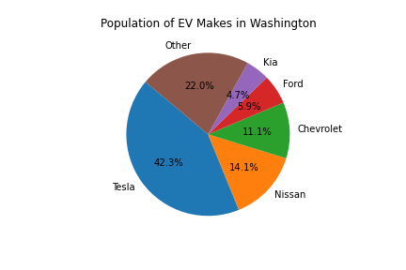

***Figure 1:*** *Pie graph representing the percentage of each make of electric vehicle owned in Washington.*

**What counties of Washington have the highest number and highest percentage of electric cars?**

In order to determine which counties of Washington have the highest populations of electric cars (EVs), the Electric Vehicle Population Size History dataset was utilised. The *loc* function was used to create a dataframe with the most recent data from October 31 2021.

It was found that as of October 31 2021, Washington had 82851 total electric vehicles, making up 1.36% of their total vehicles. San Juan has the highest percentage of electric vehicles out of total vehicles with 2.96% (600 electric vehicles out of 20267 total vehicles). King, Washington has by far the highest count of electric vehicles with 43352 vehicles, making up 2.78% of their total vehicles.

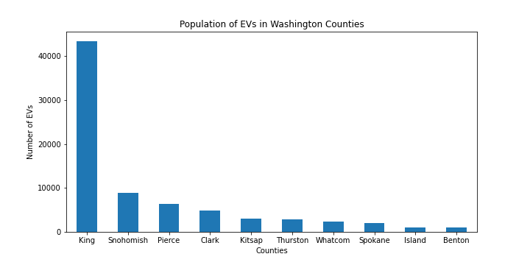

***Figure 2:*** *Bar graph representing electric vehicle count in each county of Washington.*

The heatmap of Figure 3 was created using the same data as well as manually sourced data for the coordinates of each Washington county. This heatmap shows a high concentration of electric vehicles in the west of Washington, centred around Seattle. Seattle is Washington’s largest city and is in the county of King. This demonstrates the high population of electric vehicles in King.



***Figure 3:*** *Heatmap of electric vehicle population in Washington.*

We originally intended to use this dataset to also find the population of electric vehicles across all US states. Analysis of the data showed that despite this dataset including data for various US states, there was far more data available for Washington and its counties than data available for the other states and counties. For example, the data summarised that Wisconsin only has a total of 4 electrical and non-electrical vehicles, which is highly inaccurate. Because of this, we concluded that the dataframe does not include all vehicle data for other states as expected, and thus we decided to reduce the data to only include Washington data, in order to prevent incorrect insights from other state data in our analysis.

**What has the highest population in Washington out of battery EVs or plug-in EVs?**

To determine the type of electric vehicle that is most popular in Washington, the Electric Vehicle Population Size History dataset was utilised. The *loc* function was used to create a dataframe with the most recent data from October 31 2021.

Battery electric vehicles (BEVs) have a battery instead of a gasoline tank and an electric motor instead of an internal combustion engine. Plug-in hybrid electric vehicles (PHEVs) are vehicles that possess a battery, an electric motor, a gasoline tank, and an internal combustion engine.

Our analysis found that as of October 31 2021, there are 61,335 (73.9%) total battery electric vehicles and 21,719 (26.1%) total plug-in hybrid electric vehicles in Washington. This shows that battery electric vehicles are more popular than plug-in hybrid electric vehicles. We predict that this is likely because Tesla was found to be the most popular electric vehicle brand in Washington, and all but one of Tesla’s vehicle models are battery electric vehicles. Additionally, electric vehicle customers may want to use more environmentally-friendly fuel sources, and thus may avoid vehicles that use gasoline including hybrid vehicles.

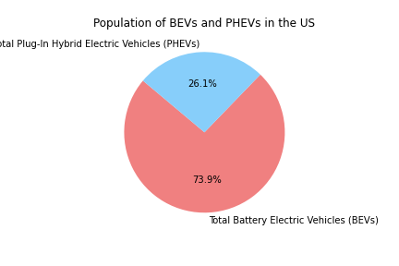

***Figure 4:*** *Pie graph representing the percentage of plug-in hybrid electric vehicles and battery electric vehicles owned in Washington.*

**How has the adoption of electric vehicles changed over time in Washington?**

The Electric Vehicle Population Size History dataset was used to analyse the change in population of electric vehicles between January 31 2017 and October 31 2021. From Figures 5 and 6 below, we can see that both the population and percentage of electric vehicles has consistently increased over the time recorded in the dataset.

We used this data to estimate that by January 31 2025, the population of electric vehicles in Washington may increase to 123,579, which may be 1.89% of a potential 6,522,205 vehicles in Washington at that time.

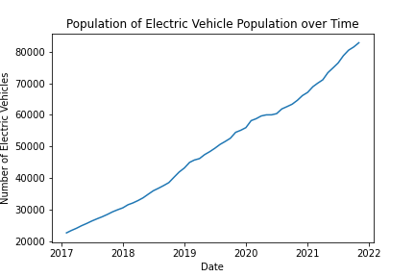

***Figure 5:*** *Number of electric vehicles in Washington over time, ranging from January 2017 to October 2021.*

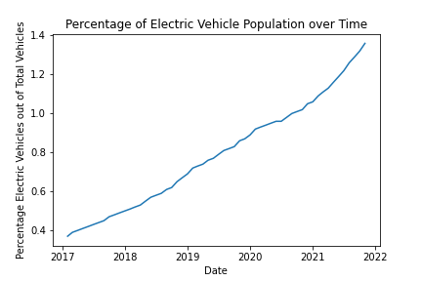

***Figure 6:*** *Percentage of electric vehicles out of total vehicles in Washington over time, ranging from January 2017 to October 2021.*

***Conclusions***

From our analysis, we can conclude that the population of electric vehicles in Washington has steadily increased since January 2017, and will likely continue to increase at a similar pace in the future. As of October 31 2021, Washington had 82,851 electric vehicles, making up 1.36% of their total vehicles.

The Washington county of San Juan has the highest percentage of electric vehicles out of total vehicles with 2.96% (600 electric vehicles out of 20267 total vehicles), while the county of King has by far the highest count of electric vehicles with 43352 vehicles, making up 2.78% of their total vehicles.

Tesla is by far the most popular manufacturer of electric vehicles in Washington with 36443 vehicles (42.3% of population). Additionally, there are 61,335 (73.9%) total battery electric vehicles and 21,719 (26.1%) total plug-in hybrid electric vehicles in Washington. This shows that battery electric vehicles are more popular than plug-in hybrid electric vehicles. We predict that this is likely because electric vehicle customers may want to use more environmentally-friendly fuel sources, and thus may avoid vehicles that use gasoline including hybrid vehicles.

We believe this data analysis could be useful for electric vehicle brands to determine the market demand of electric vehicles in Washington. This could include determining locations to advertise their vehicles and establish dealerships, as well as identifying which make and type of electric vehicle is most popular. Our analysis also demonstrates a steady increase of electric vehicle population in Washington, which is useful information to indicate to brands, shareholders, and other stakeholders that there is consistent demand for electric vehicles in Washington.